**Building Dashboards with flexdashboard**

Good resource 🡪 <https://rmarkdown.rstudio.com/flexdashboard/index.html>

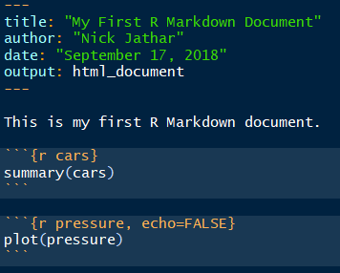

R code chunks

Narrative text written in Markdown

YAML header

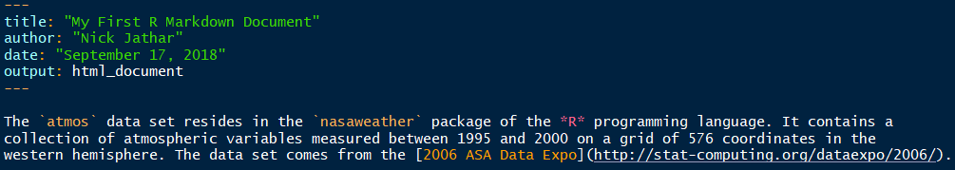

In the above narrative there are various formatting instructions…

`…` monospace * bulleted list

*…* italics 1. numbered list

##... level 2 header **…** bold

[…](…) url

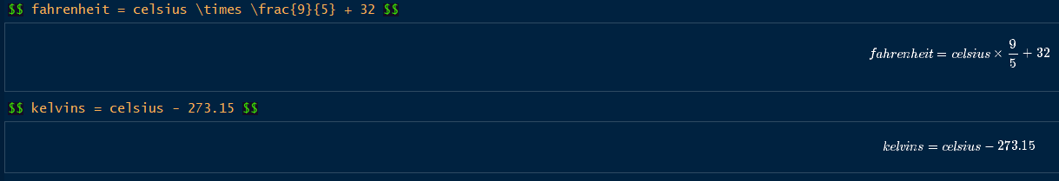

Code above shows how to use the Markdown syntax to embed latex math equations.

R code can be run in chunks using the knitr ```{r} … ``` operator.

You can also embed code in-line by using the knitr `r … ` operator.

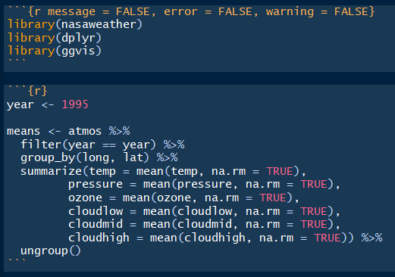

In addition to the message, error, and warning arguments, you can also use various other arguments to make the document visually more appealing and concise.

echo = FALSE R Markdown will not display the code in the final document (but it will still run the code and display its results unless told otherwise).

eval = FALSE R Markdown will not run the code or include its results, (but it will still display the code unless told otherwise).

results = ‘hide’ R Markdown will not display the results of the code (but it will still run the code and display the code itself unless told otherwise).

fig.height and fig.width are used to control the dimensions of the figures that are displayed.

```{r label_name, … ``` label_name assigns a name to a code chunk that can later be referenced by another code chunk by adding ```{r ref.label = “label_name”, … ``` This allows for code reusability.

***Additional resource for knitr*** 🡪 <https://yihui.name/knitr/options/>

Other output: formats include 🡪 pdf_document, beamer_presentation, ioslides_presentation, and slidy_presentation

When you use *** in the document, this creates a page break in the slide presentation.

You can customize your output by overwriting the templates’ default options by modifying the YAML header. Indentation is critical for the YAML header to compile properly. The following url 🡪 <http://www.rstudio.com/wp-content/uploads/2015/03/rmarkdown-reference.pdf> is a good reference guide for Markdown syntax, Knitr chunk options, and Pandoc options.

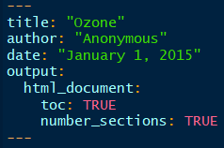

You can customize css in very specific ways by writing a .css file for your report and saving it in the same directory as the .Rmd file. To have your report use the CSS, set the cssoption of html_document to the file name, like this:

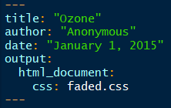

You can add shiny components to an R Markdown file to make an interactive document. When you do this, you must ensure that you use an HTML output format (like html_document, ioslides_presentation, or slidy_presentation).

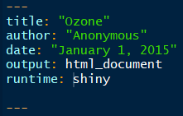

You can also use R Markdown to create reports that use interactive ggvis graphics. ggvis relies on the shiny framework to create interactivity. You do not need to wrap your interactive ggvis plots in a render function. They are ready to use as is in an R Markdown document.

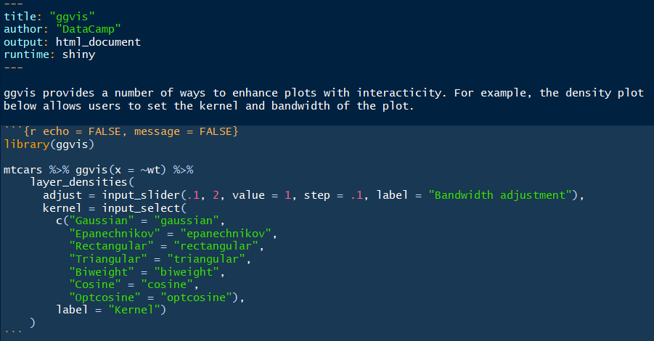

**Installing components to support the full suite of R Markdown features…**

1. LaTex 🡪 latex-project.org/ftp.html

*The three packages below come installed with RStudio:*

1. pandoc
2. rmarkdown
3. knitr